|  |
| --- |
|  |
| Test Plan |
|  |
|  |
|  |
|  |

|  |
| --- |
|  |

Contents

Test Plan 2

TennisScoreApp 2

Appendix 7

Appendix 1 7

Appendix 2 7

Appendix 3 8

Appendix 4 8

Appendix 5 9

Appendix 6 9

Appendix 7 10

Appendix 8 10

Appendix 9 11

Appendix 10 11

Appendix 11 12

Appendix 12 12

Appendix 13 13

Appendix 14 13

# Test Plan

## TennisScoreApp

|  |  |  |  |  |
| --- | --- | --- | --- | --- |
| What is being tested? | Testing Method | Expected Result | Actual Result | Actual Result Evidence |
| Application runs | Run the application | Application will open | Application opened | Appendix 1 |
| Player Name1: User Input | Input name to UITextField | When UITextField is clicked the keyboard appears allowing for input | When UITextField was clicked the keyboard appeared allowing for input | Appendix 2 |
| Player Name1: User Input | Input name to UITextField | When UITextField is clicked the keyboard appears allowing for input | When UITextField was clicked the keyboard appeared allowing for input | Appendix 3 |
| Best of 3: Button | Press Best of 3 Button | When pressed Bestof label will change value to set number | When pressed Bestof label changed value to set number | Appendix 4 |
| Best of 5: Button | Press Best of 5 Button | When pressed Bestof label will change value to set number | When pressed Bestof label changed value to set number | Appendix 5 |
| Player1Labe1: Name change | Input name to UITextField and press Best of 3 Button | After name is input and button is pressed the label will change to the name input | After name was input and button was pressed the label changed to the name input | Appendix 4 |
| Player2Label1 Name change | Input name to UITextField and press Best of 3 Button | After name is input and button is pressed the label will change to the name input | After name was input and button was pressed the label changed to the name input | Appendix 5 |
| S1 :Update server | Player 1 button pressed | After the player 1 button is pressed the server will change and show a red ‘S’ | After player 1 button was pressed the server changed and showed a red ‘S’ | Appendix 6 |
| S2: Update server | Player 2 button pressed | After the player 2 button is pressed the server will change and show a red ‘S’ | After the player 2 button is pressed the server changed and showed a red ‘S’ | Appendix 9 |
| Player1GameLabel: Update score | Player 1 button pressed | After the player 1 button is pressed the score will go up by ‘15’ | After the player 1 button was pressed the score increased by ‘15’ | Appendix 6 |
| Player2GameLabel: Update Score | Player 2 button pressed | After the player 2 button is pressed the score will go up by ‘15’ | After the player 2 button was pressed the score increased by ‘15’ | Appendix 8 |
| Player1GameLabel: Advantage | Player 1 button pressed | After the player 1 button is pressed when the scores are ‘40’ player 1 score will turn to ‘A’ | After the player 1 button was pressed when the scores were ‘40’ player 1 score turned to ‘A’ | Appendix 8, Appendix 10 |
| Player2GameLabel:  Advantage | Player 2 button pressed | After the player 2 button is pressed when the scores are ‘40’ player 2 score will turn to ‘A’ | After the player 2 button was pressed when the scores were ‘40’ player 2 score turned to ‘A’ | Appendix 8, Appendix 9 |
| Player1GameLabel: Game win | Player 1 button pressed | After the player 1 button is pressed after player 1 has the advantage or better score the set score will increase by 1 and game scores reset | After the player 1 button is pressed after player 1 had the advantage or better score the set score increase by 1 and game scores reset | Appendix 7 |
| Player2GameLabel: Game win | Player 2 button pressed | After the player 2 button is pressed after payer 2 has the advantage or better score the set score will increase by 1 and game scores reset | After the player 2 button was pressed after payer 2 had the advantage or better score the set score increase by 1 and game scores reset | Appendix 11 |
| Player1SetLabel: Tiebreaker best of 3 | Player 1 button pressed | After the player 1 button is pressed when the set score is ‘1’ and player 2 set score is ‘1’ Player 1 will win the set | After the player 1 button is pressed when the set score was ‘1’ and player 2 set score was ‘1’ Player 1 won the set | Appendix 11 |
| Player2SetLabel: Tiebreaker best of 3 | Player 2 button pressed | After the player 2 button is pressed when the set score is ‘1’ and player 1 set score is ‘1’ player 2 will win the set | After the player 1 button was pressed when the set score was ‘1’ and player 2 set score was ‘1’ Player 2 won the set | Appendix 11 |
| Player1SetLabel: Tiebreaker best of 6 | Player 1 button pressed | After the player 1 button is pressed when the set score is ‘2’ and player 2 set score is ‘2’ Player 1 will win the set | After the player 1 button was pressed when the set score was ‘2’ and player 2 set score was ‘2’ Player 1 won the set | Appendix 12 |
| Player2SetLabel: Tiebreaker best of 6 | Player 2 button pressed | After the player 2 button is pressed when the set score is ‘2’ and player 1 set score is ‘2’ Player 2 will win the set | After the player 2 button was pressed when the set score was ‘2’ and player 2 set score was ‘2’ Player 2 won the set | Appendix 12 |
| Player1SetLabel: Game win | Player 1 button pressed | After the player 1 button is pressed when the set score is equal to the best of sets Player 1 will win the match | After the player 1 button was pressed when the set score was equal to the best of sets Player 1 won the match | Appendix 13 |
| Player2SetLabel: Game win | Player 2 button pressed | After the player 2 button is pressed when the set score is equal to the best of sets Player 2 will win the match | After the player 2 button was pressed when the set score was equal to the best of sets Player 2 won the match | Appendix 14 |
| Player1: Win Alert | Player 1 button pressed | After the player 1 button is pressed and Player 1 wins the match an alert will pop up stating winner | After the player 1 button was pressed and Player 1 won the match an alert popped up stating winner | Appendix 13 |
| Player2: Win Alert | Player 2 button pressed | After the player 2 button is pressed and Player 2 wins the match an alert will pop up stating winner | After the player 2 button was pressed and Player 2 won the match an alert popped up stating winner | Appendix 14 |

# Appendix

## Appendix 1

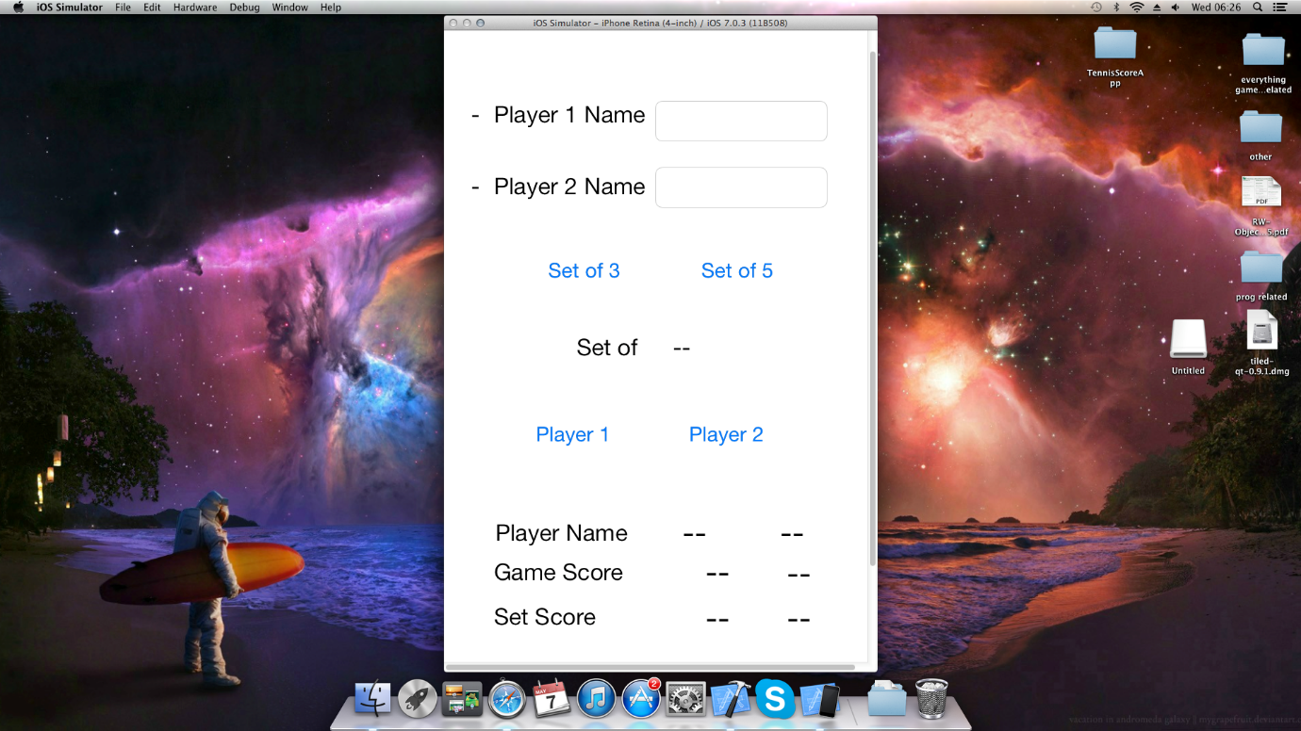

## Appendix 2

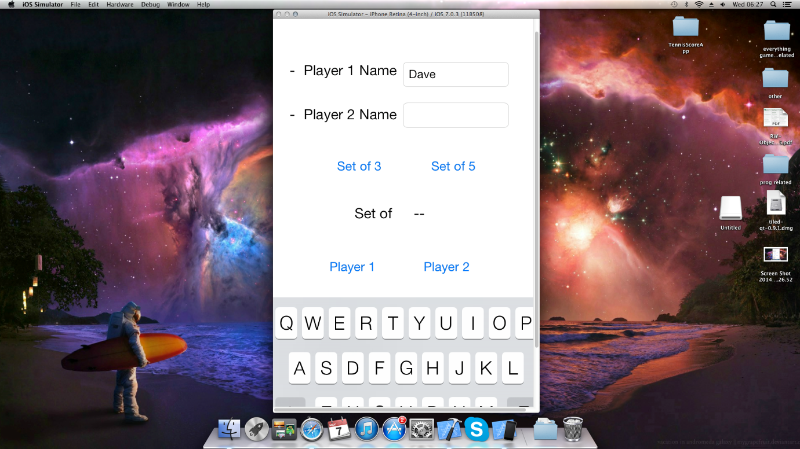

## Appendix 3

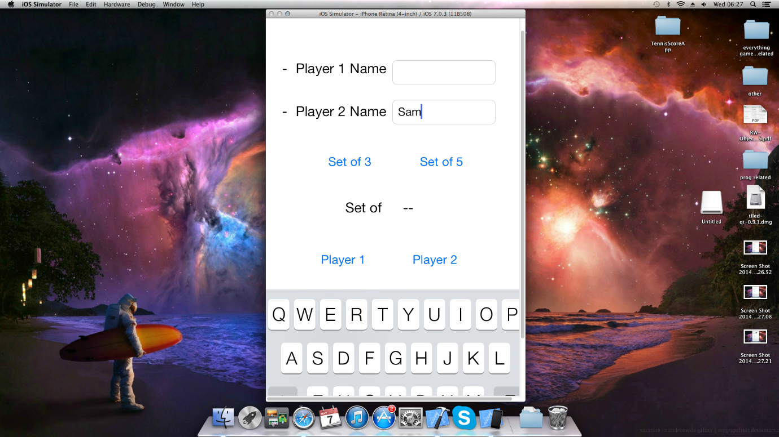

## Appendix 4

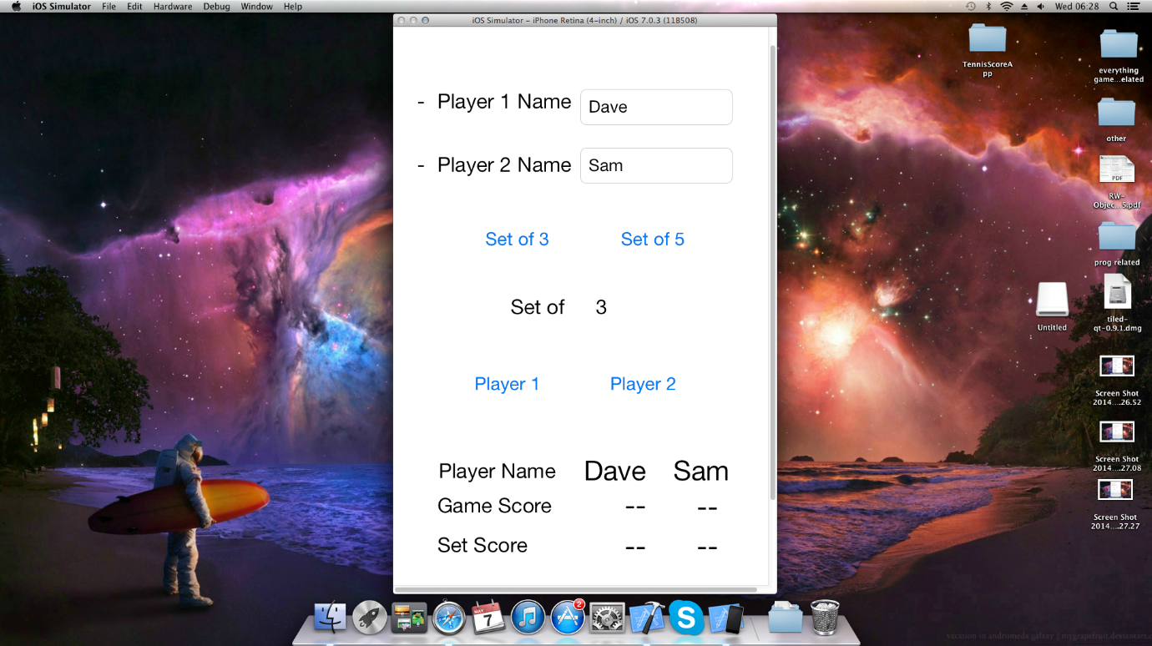

## Appendix 5

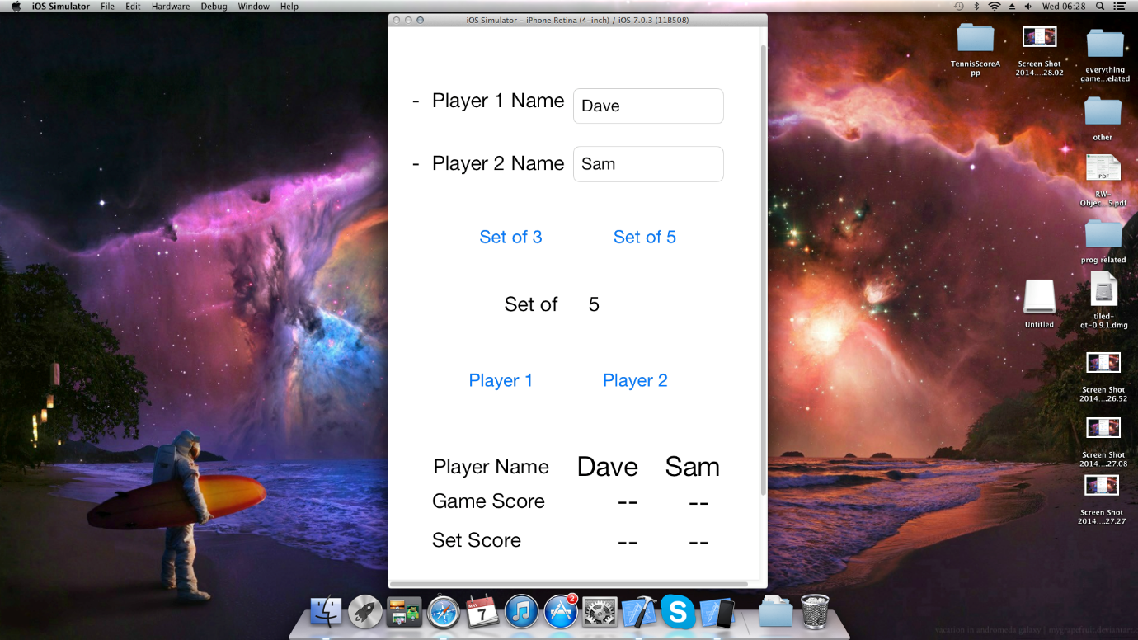

## Appendix 6

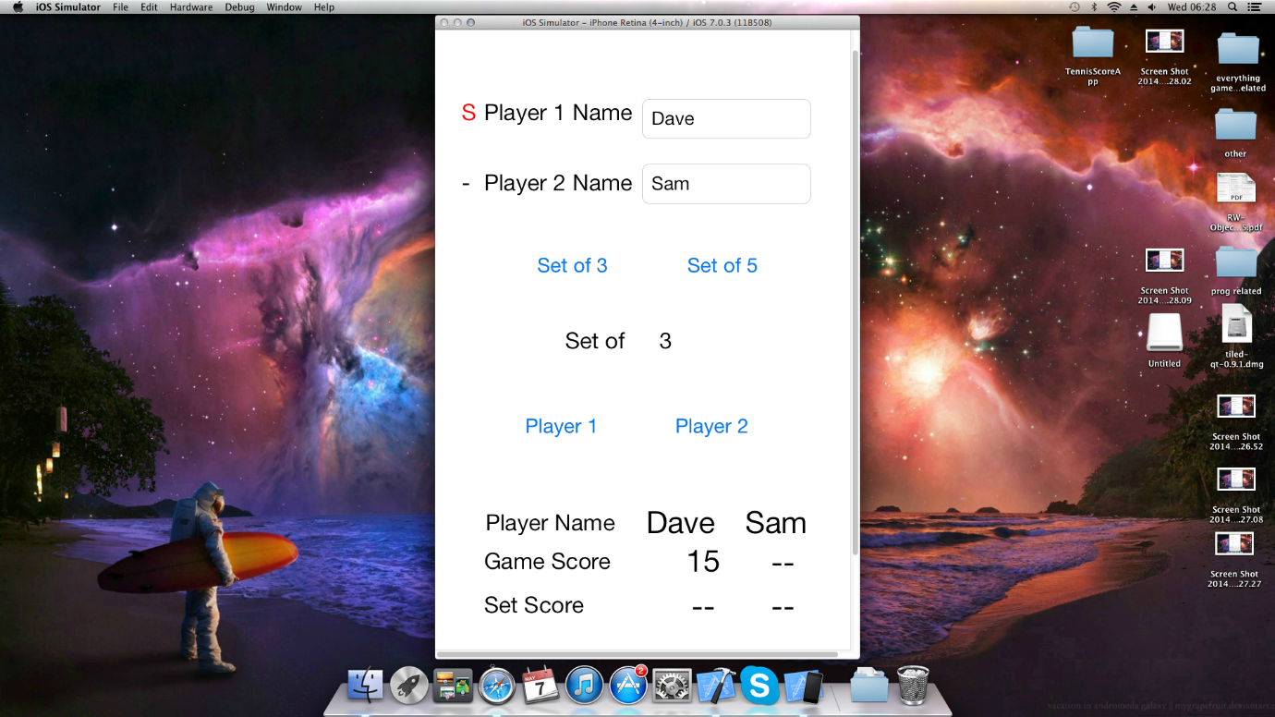

## Appendix 7

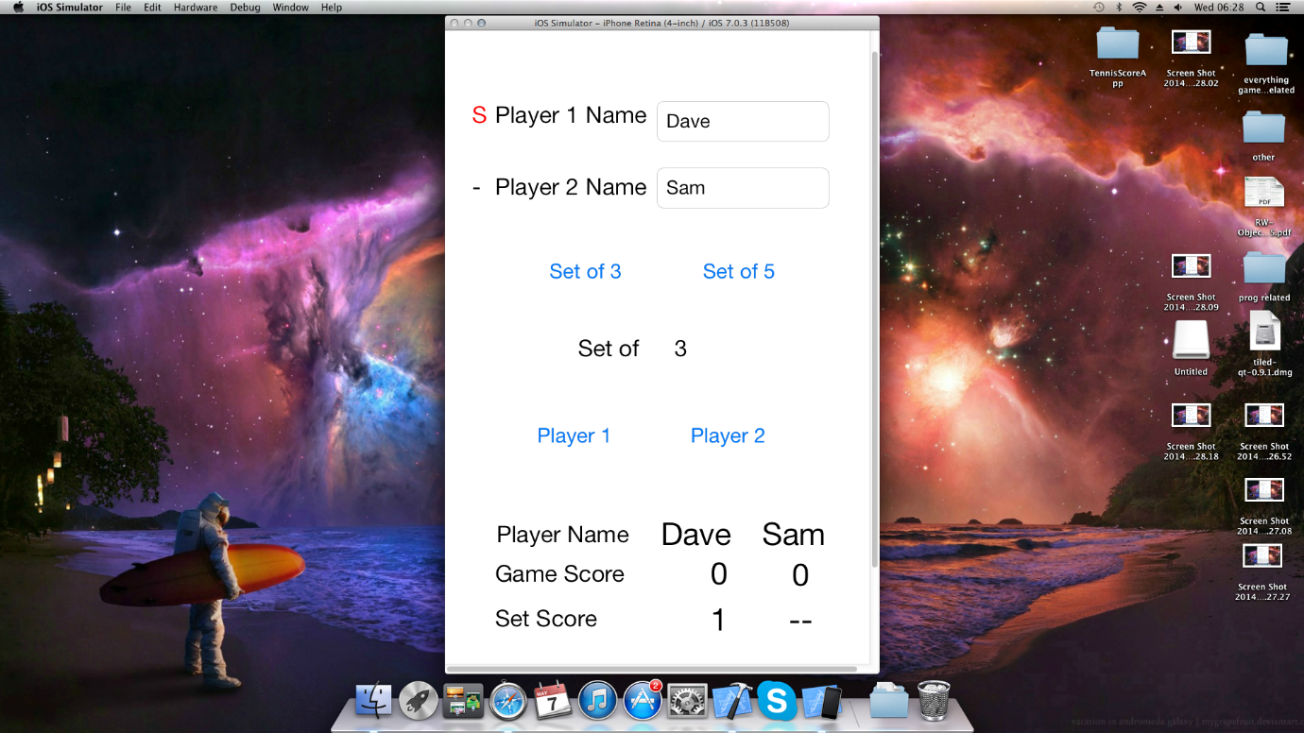

## Appendix 8

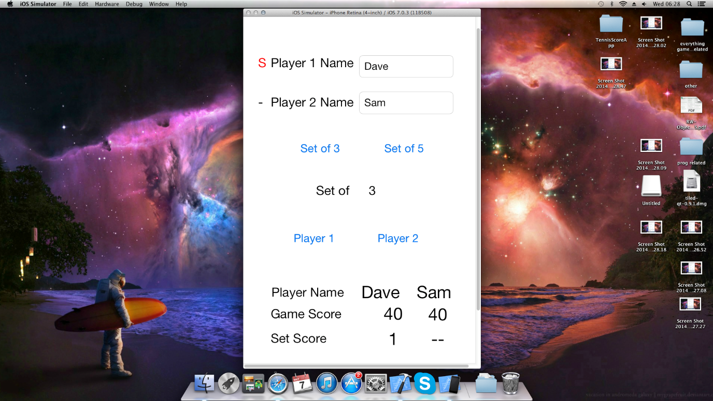

## Appendix 9

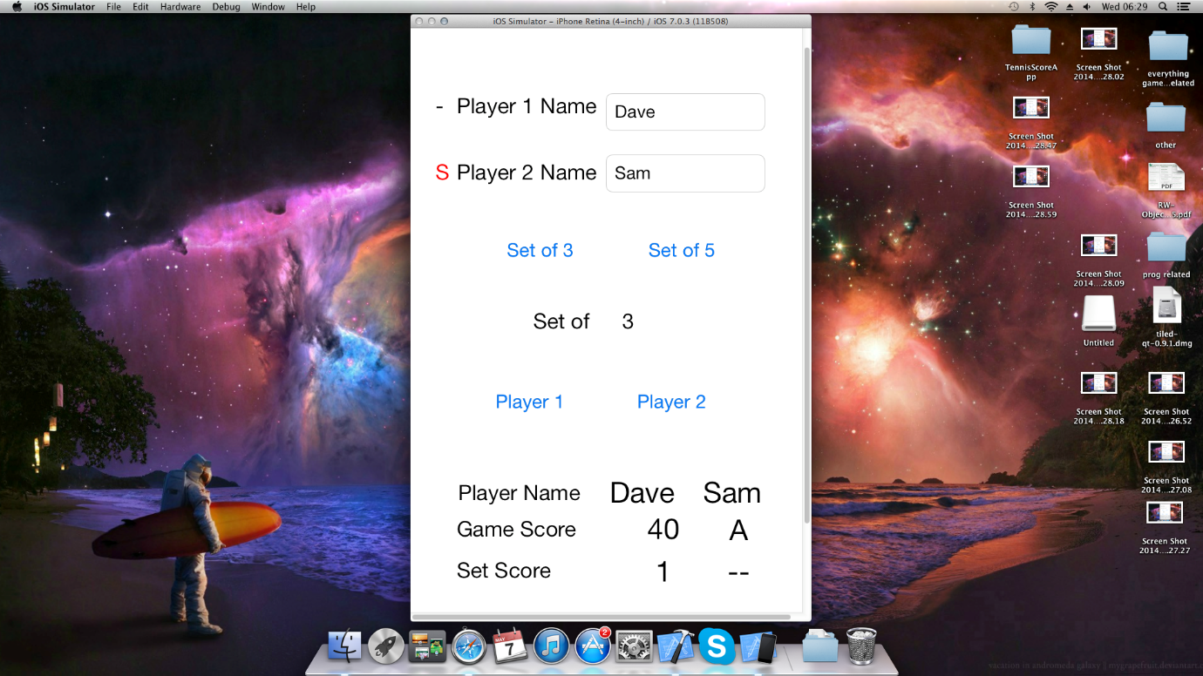

## Appendix 10

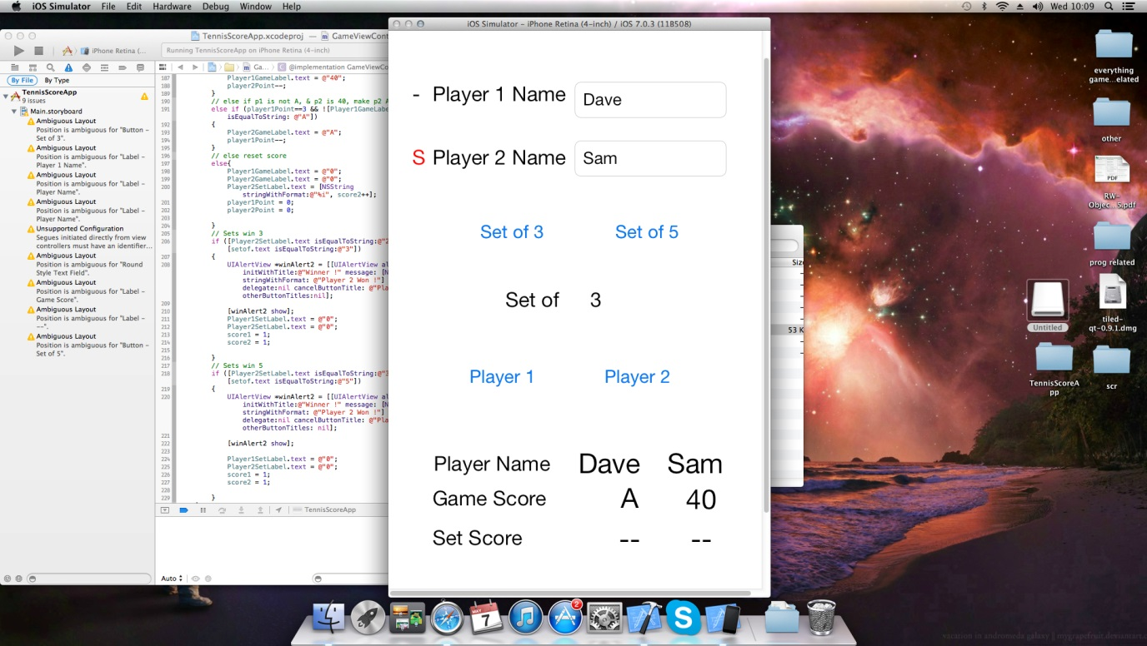

## Appendix 11

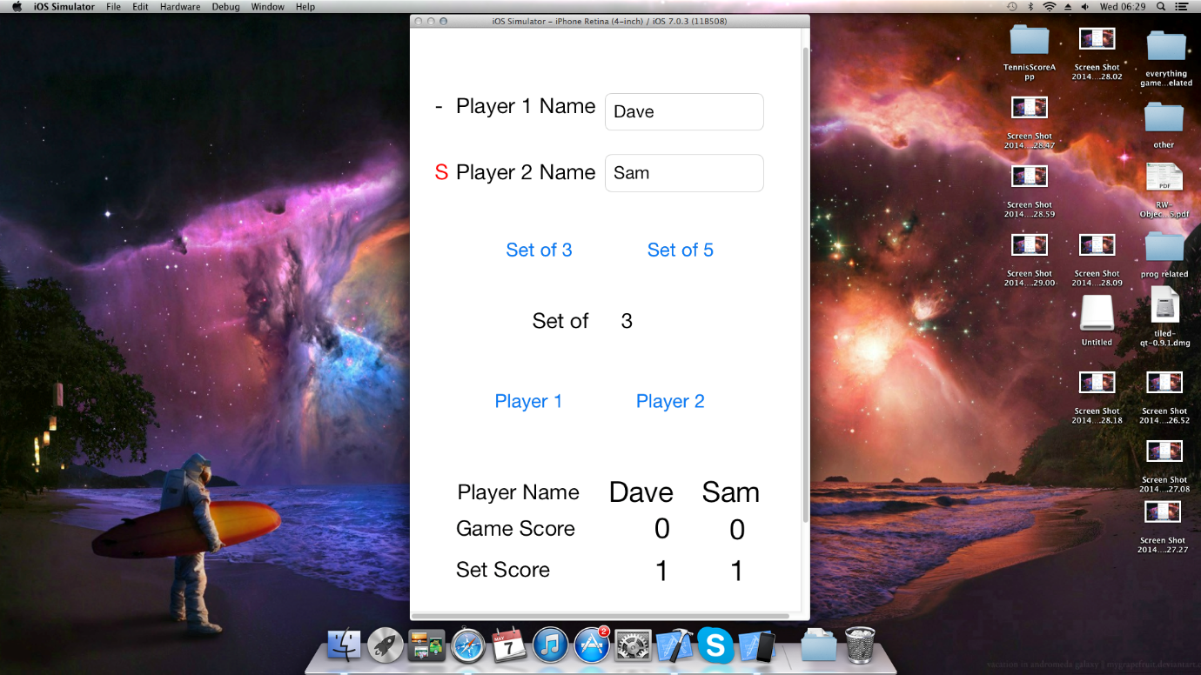

## Appendix 12

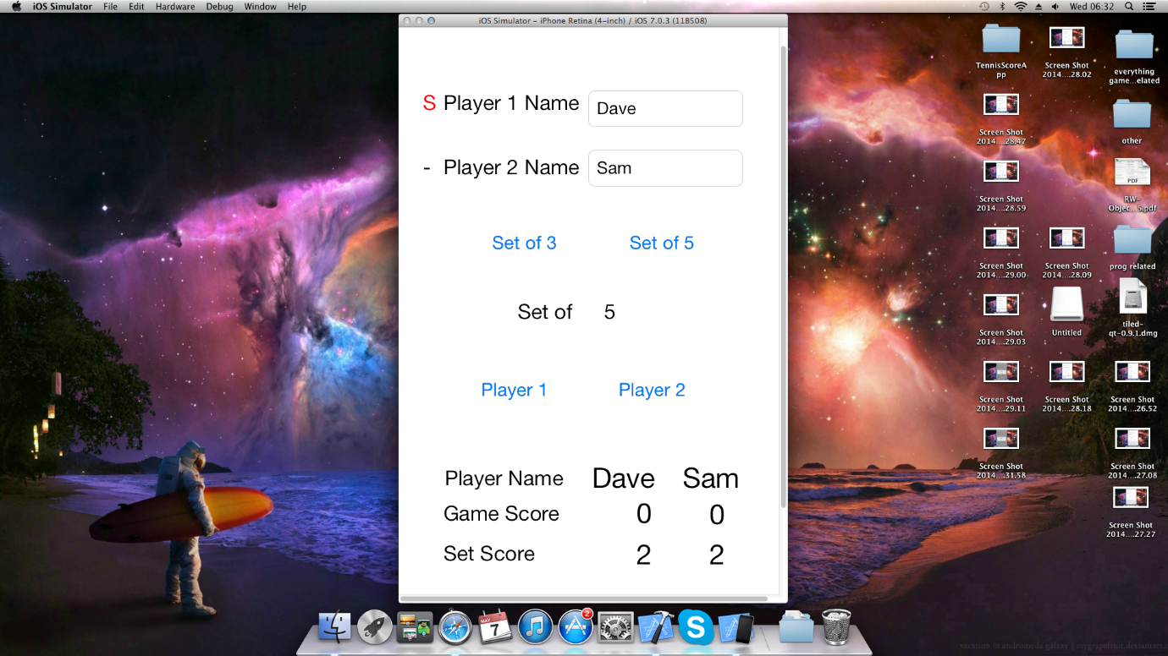

## Appendix 13

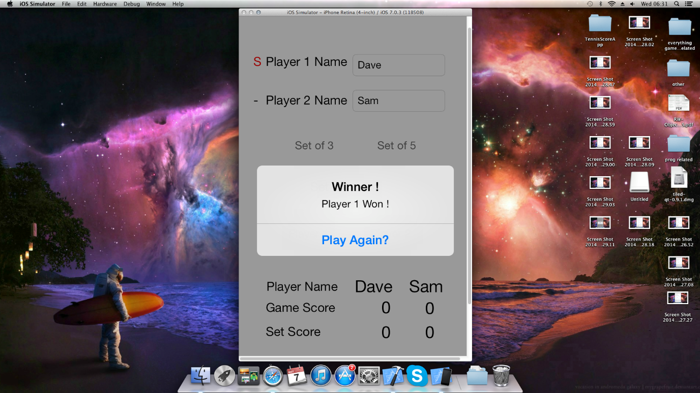

## Appendix 14

